VIRTUAL ROUTINE GRADE GUIDE FOR CLUBS.

This guide is to layout the protocols that must be followed to participate in a virtual grade day. It also will provide some key point you must follow to avoid swimmers receiving 0s or being disqualified.

Timeline
  - 3 September 2025
Your regional organizer will need to know Who you want to enter and what grades you want to enter. These should be entered on the normal application sheet.
You will at this point be asked at this point submit the names and email addresses of the judges that will be representing you. Please ensure that you do have the personal address for your judges as this will be used to share the files that they will judge.

  - Sunday 7 September 2025
You will receive a form to tell you the swimmer number for the swimmers that they have entered.

Eg Grade 1 Fred Bloggs will be swimmer 4
Grade 2 Mary Smith will be swimmer no 1

YOU WILL ALSO BE ASSIGNED A THREE NUMBER CLUB CODE eg. Rugby may be 745.

  - Saturday 13 September 2025 - Video Submission Date

A File share will be set up for submission of videos. A folder will then be shared with your club coordinator so that they have access to upload their video files for each swimmer.

ALL VIDEOS MUST SHOW;
- SHOW THE SWIMMER FACING THE CAMERA ON THE SURFACE BEFORE THEY START EACH ELEMENT
- THE FULL LENGTH OF THE BODY AT ALL TIMES BOTHE VERTICALLY AND HORIZONTALLY
- MUST BE FREE FROM GLARE OR SHADE THAT OBSTRUCTS THE VIEW OF WATER LEVEL OR BODY POSITION.
- MUST BE KEPT IN ONE POSITION AND NOT TRAVEL WITH THE SWIMMER TO SHOW THE SWIMMERS TRAVEL.
- SPLITS SHOULD ALSO BE A VIDEO SHOWING THE SWIMMER HOLDING THE POSITION FOR 5 SECONDS AND AGAIN CLEARLY SHOW ALL OF THE BODY AND LEG POSITION.
- If the swimmer is not flat then blocks should be placed by the hips to judge the distance from the ground. Only 10cm blocks to be used.

IF THEY DO NOT COMPLY WITH THESE POINTS THE SWIMMER WILL BE GIVEN 0 FOR THAT ELEMENT.

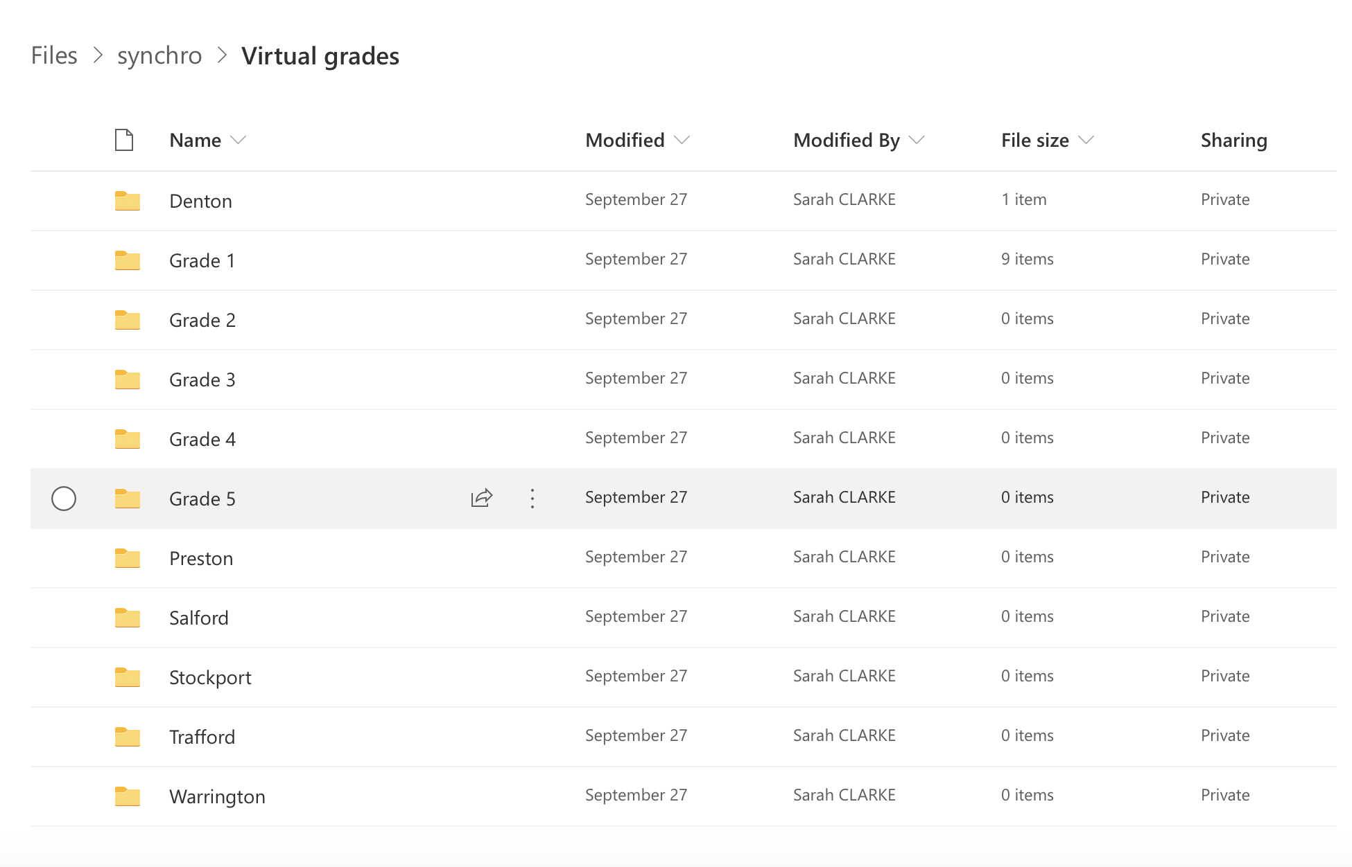

You can then start to submit their video files to their correct folder, ensure the right swimmer is put into the right grade.

Each video will be labelled not with names but with swimmer numbers in the following format;

Grade being sat_swimmer number (sent on return of entries from the organiser)_club number code(try to remove club bias)_element number

FG4_S6_123_E1

ANY VIDEOS NOT CORRECTLY SUBMITTED THAT SWIMMER WILL BE DISQUALIFIED!

  - After Video submission date.
All videos then are moved into the correct grade and element folders in the same file.

Once all videos are in the correct folder, the folders then need to be shared with the correct judges according to the clubs entries.

Each folder will also contain the judge's spreadsheet for the judges to return their marks.

  - 19 to 21 September 2025
All judges should return their results by midnight on 21 September 2025.

At this point results need to be copied and pasted into the normal grade day spreadsheet.

NO RESULTS WILL BE RELEASED UNTIL THE SENIOR JUDGE HAS APPROVED THEM (AFTER CARRYING OUT A MODERATION PROCESS).

Results will be sent out as soon as possible.
Certificates and Badges will be passed over to clubs at the next Face to Face Grade day or sent out by post.

Entry form for

First Name | Surname | DOB | Swim England Number | Club | Region | Grade type | Grade level held | Date taken | Grade type to be taken | Grade level to be taken
Eg Katie | Smith | 10/5/00 | 012345 | New York Knicks | NW | Figure | 3 bronze | 1/1/17 | Figure | 4

