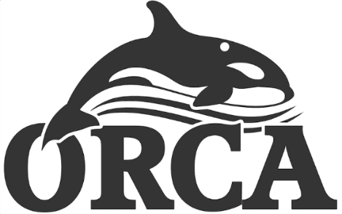

ORCA Swimming Club – Head Coach Vacancy

As we enter our 10th successful year as a fully constituted Swim England affiliated swimming club, we are seeking a new motivating and inspiring Head Coach to join the existing coaching team and to lead the development of our competitive swimming programme. We are an ambitious, friendly and community-focused club operating out of Royton Leisure Centre and are committed to providing high-quality coaching and a positive, inclusive environment for swimmers of all ages and abilities.

If this sounds like the role for you, please contact the ORCA club secretary for the job description and person specification and then submit your CV and personal statement demonstrating your suitability for the role against this criteria to Secretary@orcaswimming.club

Closing date for applications is noon on Friday 12th June 2026.

For more information on the club, please visit our website - ORCA Swimming Club – Make Every Lap Count

